These steps are for running in NetBeans 7.4 or 8.0 with C/C++ plugins:

1. Assuming that you are using header file I’ve send:
   1. Create project with name - JNIDemoJava (Do Not Create Main Class).
   2. Create package with name – jnidemojava.
   3. Add all 3 java files in it. (Namely – Clk.java, Main.java, UDPServer.java).
   4. Create C project selecting Dynamic library with name – JNIDemoCdl.
   5. Go to project folder which will be named as JNIDemoCdl.
   6. Here copy ‘.c’ file and ‘.h’ file named as – JNIDemo.c and JNIDemoJava.h.
   7. Now make changes in properties of JNIDemoCdl – C project as shown below.
   8. Go to C Compiler node which is under Build node.
   9. There browse Include Directories and add path of JDK/include directory and add path of JDK/include/linux, shown in fig below.

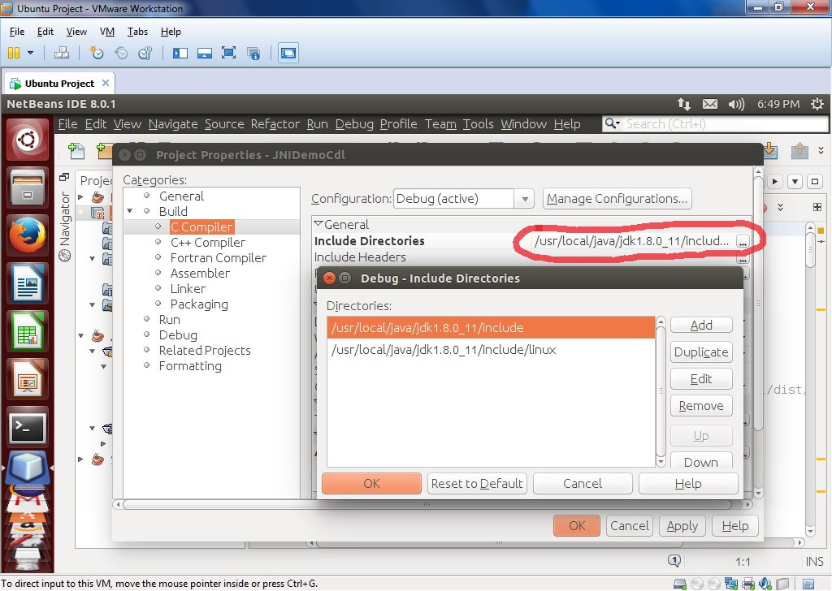

* 1. At end of same tab of “C Compiler”, there is “Additional Options” under “Compilation Line”. There add text “-shared –m64”. As shown in fig below:

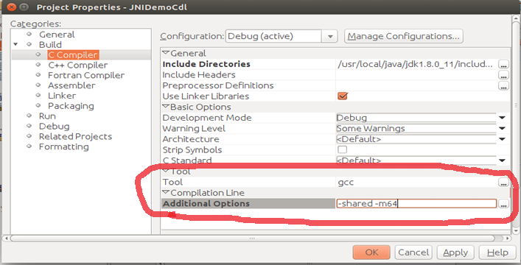

* 1. Now to set output location of “.so” file, go to linker tab there is option called Output set the location for output of “.so” file to dist/libJNIDemoCdl.so. It will create libJNIDemoCdl.so in dist folder of project folder (netbeans project/JNIDemoCdl/dist/).
  2. Now Clean and Build C Project file, if it builds successfully then clean and build Java Project.
  3. Now run java project. If it asks for main class set UDPServer as main class.

Note: Project name of Java project and C header file must be same